[1] Keys and Couplings – Machine Design

Keys and Couplings

Chapter Objectives
- Design the section of the most commonly used rectangular key on the basis of torque and allowable shear and bearing stresses in key.
- Design the thickness and radius of semicircular portion of Woodruff key on the basis of torque and allowable shear and bearing stresses in key.
- Design the section of a spline in a splined shaft on the basis of torque and allowable normal stress on spline.
- Design the section of Kennedy's key for heavy torque transmission on the basis of allowable shear and bearing stresses in key.
- Design a rigid coupling for two shafts on the basis of torque, allowable shear stress in flange, in bolts connecting two flanges and in hub of the coupling.
- Provide a spigot (projected portion on one flange) to fit in the recess (socket portion) of another flange.
- Design the marine type flange coupling on the basis of empirical relations and torque to be transmitted.
- Design the flexible element in flexible coupling in addition to the design of hub, flanges and bolts.
- Design a clamp coupling on the basis pf clamping force and frictional force between shafts and muff.

1-1 INTRODUCTION
IC engines, turbines, rotating elements like wheels, gears, pulleys and sprocket are connected with the help of a key between the shaft of a prime mover and the hub of a rotating element. Keyways are cut in to the shaft and the hub, and a key is inserted in to the keyways to provide a mechanical joint between the shaft and the hub. Power is transmitted from the shaft to a rotating element through the key. There are several types of keys, such as rectangular key, woodruff key, round key, saddle key, etc., depending upon the magnitude of the torque to be transmitted. The keyways create a region of stress concentration both in shaft and hub. To eliminate key and keyways, the shaft and hub can be force fitted or shrink fitted. However, during disassembly a special pulling machine is to be used to pull the coupled element out of the shaft.
In many cases, two shafts (of prime mover and driven machine) are directly coupled together for power transmission. Based on the type of the alignment between the shafts, and the angular position of the shaft axes, there are different types of couplings, such as rigid flange type, flexible type, sleeve type and clamp type.

1-2 KEYS AND KEYWAYS
As per ASME, “a key” is a demountable machinery part, which, when assembled into key seats, provides positive means for transmitting torque between the shaft and the hub. Keys are classified on the basis of their size and shape, as shown in Fig. 1-1. A parallel key is a key with constant height and width over its length. Its section is square or rectangular. The dimensions of a parallel rectangular section key are b × t × L. A tapered key is a key of constant width. However, its height varies with a linear taper of 1/100, along its length. It is driven into the tapered slot of the hub until it locks. It may have a head-gib head or a plain head. A tapered key locks the hub axially on the shaft. A woodruff key is semi-circular in plane but has a constant width. It fits in a semi-circular keyway milled in the shaft.
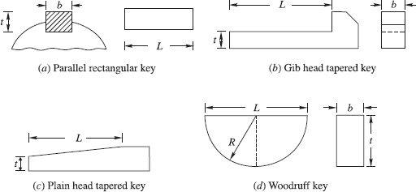
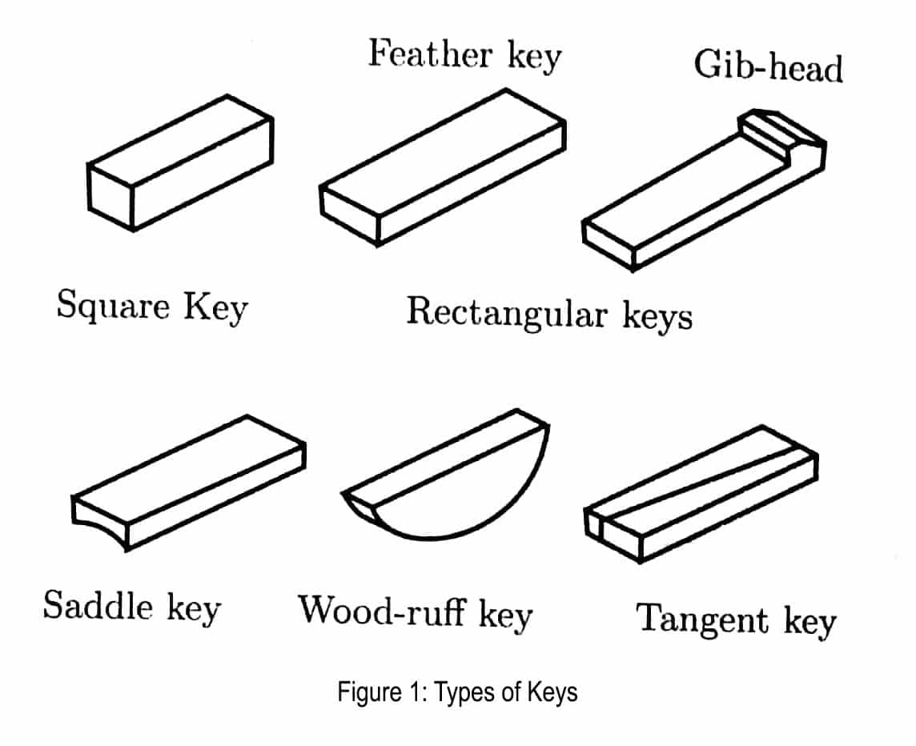
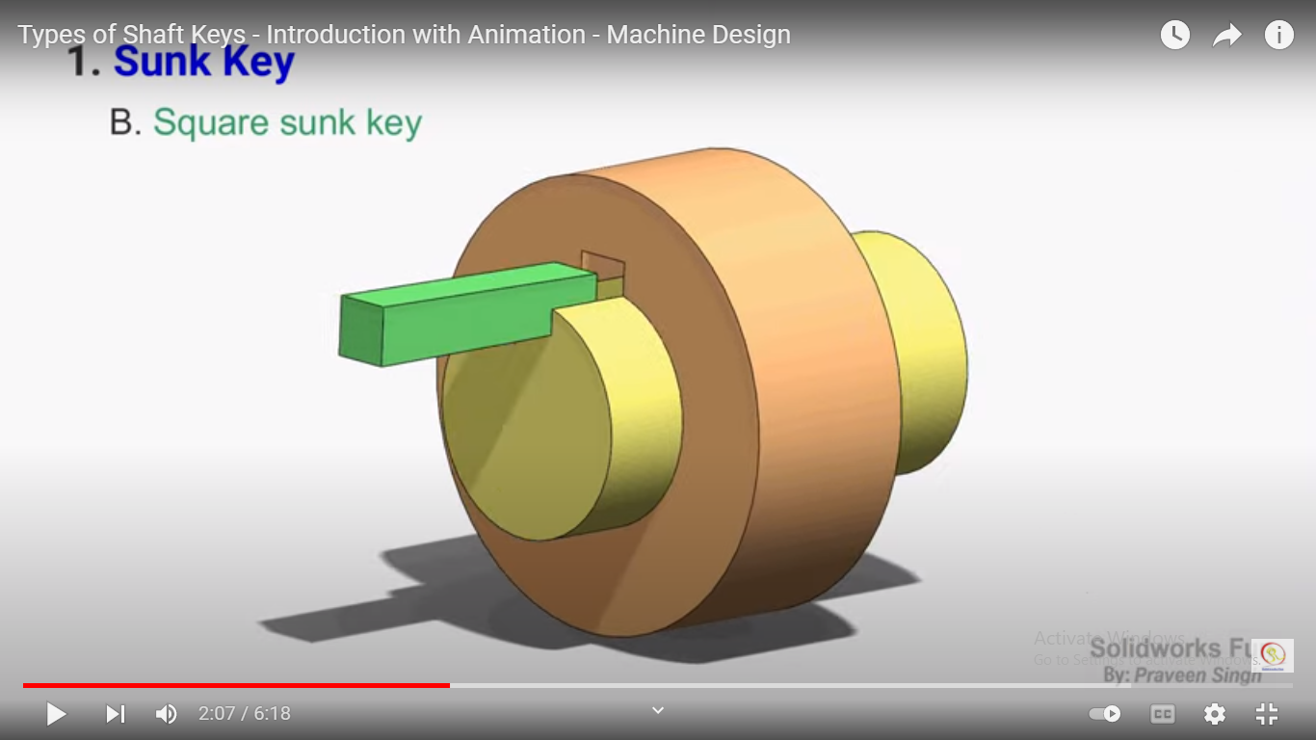
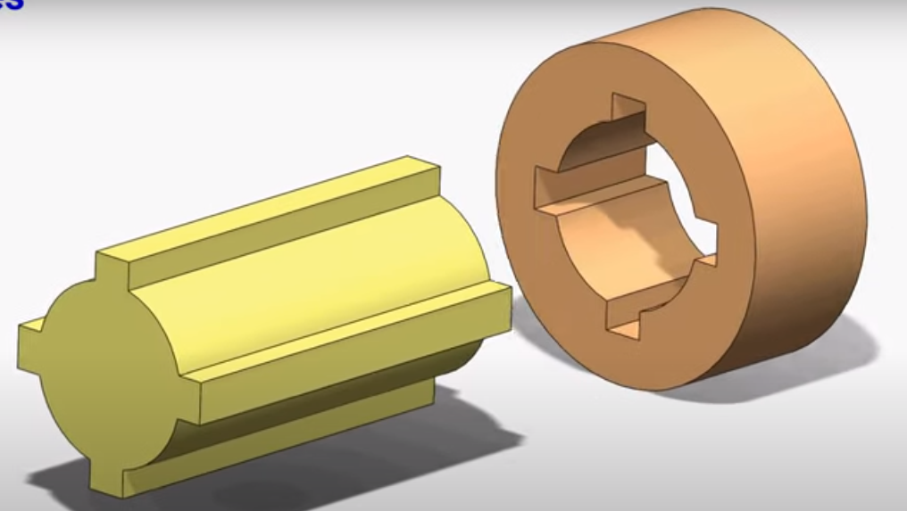
Figure 1-1 Different types of keys

Parallel and woodruff keys require some means to fix the axial position of the hub on the shaft. Retaining rings or clamp collars are used for this purpose. Parallel keys are the most commonly used keys. Square keys are used for shaft diameters up to 25 mm, and rectangular keys are used for shaft diameters of more than 25 mm. Parallel keys are made from standard, cold-rolled bars. When the torque changes sign, any clearance between the key and the keyway causes impact and high stress. This is called a backlash. A set screw in the hub, placed at 90° from the key, holds the hub axially, and stabilities the key against the backlash.
A gib head is optional and provides a surface for prying the key out when the small end is not accessible Tapered keys tend to create eccentricity between hub and shaft assembly.
Woodruff keys are self aligning, but generally used on smaller shafts. The semi-circular shape creates a deeper keyseat in the shaft, which resists key rolling but weakens the shaft, as compared to a rectangular key or a tapered key. This key accommodates itself to any taper in the hub or boss of the mating member.
Shear stress developed in key leading to shear failure:

Average bearing stress developed in key leading to bearing failure:

It is common to size the key so that it fails before the keyseat or any other location in the shaft fails in the event of an overload. Key acts like a shear pin in an outboard motor to protect the more expensive elements from damage. A key is inexpensive and relatively easy to replace. Key materials are ductile materials of lower strength.

1-3 DESIGN OF KEYS AND KEYWAYS
Mountings like gear, sheave, pulley, flywheel, are fitted on the shaft with the help of a key, so as to prevent the relative motion between the shaft and the element. A keyway is cut into hubs of rotating elements and the shaft and a key is seated between the two grooves. Open keys are usually fitted with tapered or gib-head keys, which are forced into the keyways so that friction keeps them in position. The enlarged portion of the gib key is extended beyond the gear for easy removal, but because of the possibility of catching on clothing when the shaft is rotating, it is dangerous, unless covered. A keyway introduces a change in the geometry of the shaft and it causes a stress concentration at the change in the cross-section. There is some stress concentration at the empty keyway, but when the key is fitted in the keyway the stress concentration is slightly reduced. Table 1-1 shows that partial-length keys and round-end keys are better where less SCF is developed.

Table 1-1 Stress concentration factors at key and keyway
Configuration | K_{sc}
Full-Length Key (Round-End Key), Profile Keyways
At Keyway End | 3.81
Embedded | 3.34
Partial-Length Key (Round-End Key), Profile Keyways
At Keyway End | 2.84
Embedded Near End Of Key | 1.94
Partial-Length Key (Round End Key), Sled-Runner Keyway
At Keyway End | 2.79
Embedded Near Key End | 1.66
Full-Length Key (Square-End Key), Profile Keyway
Embedded Keyway End | 5.83
From Table 1-1, it is observed that partial-length keys and round-end keys are better where less SCF is developed.
Redesign of the key and keyway, as shown in Figure 14-2, was found to reduce both the stress concentration at the end of the key, and at end of the keyway. The stress concentration can be reduced to less than 1.2 for certain fillet radii of the key, and for keyway length to width ratios. Figure 14-2 shows four corners of a key, fitted in shaft and hub. During torque transmission, the forces on the hub and the shaft are not uniformly distributed; the forces on the hub are concentrated at corner 1, and the forces on the shaft are concentrated at corner 3, as shown for clockwise rotation. Hub failure can start from region 1, while shaft failure can start from region 3 (see Fig. 14-2). Generally, the hubs are stronger than the shaft. Therefore, fatigue failure (due to reversal of stresses) starts from corner 3 in the shaft.
Based on experimental results, H. F. Moore gave the relation for the weakening effect of a keyway in the shaft in the following manner:

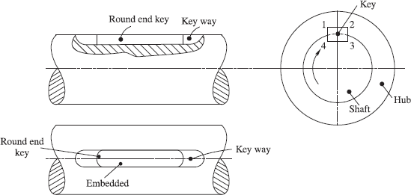

Figure 14-2 Four corners of a key fitted in shaft and hub

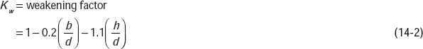

where, b = breadth of the key, and h = depth of key in the shaft.

In general practice, K_{w} = 0.75
If the keyway is too long, and key is of the sliding type, then the angle of twist is increased by factor K_{θ} in the shaft.

SOLVED EXAMPLES
Example 14-1 The dimensions of a woodruff key for a 40 mm shaft, are shown in Fig. 14-3. One third of the depth of the key is in the hub portion. The shaft transmits 6 kW at 350 rpm. The key is made of steel and σ_{yt} = σ_{yc} = 380 N/mm². Calculate the factor of safety in the design of the key.
Solution:

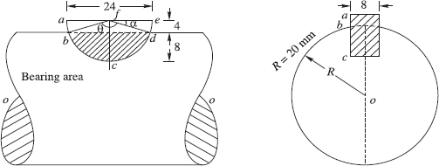

Figure 14-3
Tan α = 4/12 ; α = tan⁻¹ 4/12
Θ = 180 – 2 x α
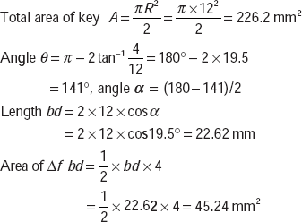

Area of key under bearing pressure = area bcd

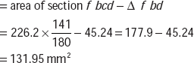

Area of key under bearing above line bd = 226.2 − 131.95 = 94.25 mm²
Area of woodruff key under shear = bd × 8 = 22.62 × 8 = 180.96 mm²
Power = 6 kW

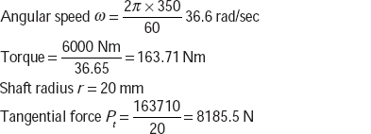

Bearing stress developed in key 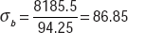
Shearing stress developed in key 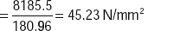
Material σ_{yt} = σ_{yc} = 380 N/mm²

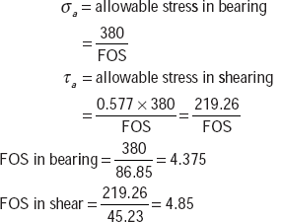

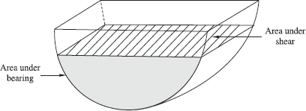

Figure 14-4 Key

14-4 SPLINES
For more torque transmission, splines are used in place of keys. These are built-in tooth-like keys formed on the outside of the shaft, and inside the hub. Earlier, splines were of trapezoidal section, with the depth of the section at the shaft less than the depth of the section at the hub. Therefore, a shaft section was weaker than a hub section. Nowadays involute splines are used (see Fig. 14-5). In this form, the depth of the spline section at the shaft is more than the depth of the spline section at the hub. The standard, involute spline-tooth forms have a 20° pressure angle. Standard splines can have from 6 to 50 teeth.

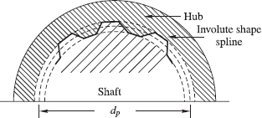

Figure 14-5 Splines

Splines provide maximum strength at the root of tooth, accuracy of tooth form, and superior machined surface finish. Splines can accommodate large axial movements between the shaft and the hub, and at the same time transmit torque. Engine torque is usually passed into the transmission through a spline which connects the engine clutch to the transmission input shaft, and allows the axial motion, which is necessary for disengaging the clutch from the flywheel. Splines are loaded under pure torsion.
If the splines are made perfectly, with no variation in tooth thickness or spacing, all the teeth would share the load equally.
Length of the spline = l
Pitch circle diameter of splines = d_{p}
Area under shear 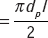
* The Society of Automobile Engineers (SAE) assumes that only 25% of the teeth are actually sharing the load at any one time.
Shear stress 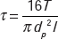 where T is the torque transmitted.

SOLVED EXAMPLES
Example 14-2 A standard splined connection, 12 × 45 × 50 mm, is used for a gear and shaft assembly, rotating at 400 rpm. The length of the gear hub is 60 mm, and the normal pressure on the splines is limited to 6.5 MPa. Calculate the power which can be transmitted from the gear to the shaft. What is the shear stress developed in the splined shaft and in the splined hub?
Solution
Number of splines n = 12
Angle 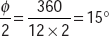
Minor radius 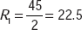 mm; Major radius 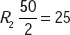 mm (see Fig. 14-6).
Length of the spline l = 60 mm
Mean radius 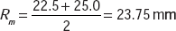
Normal pressure on spline p = 6.5 N/mm²
Normal force per spline P_{n} = (R₂ − R₁) × l × p = 2.5 × 60 × 6.5 = 975 N
Torque per spline T ′ = P_{n} × R_{m} = 975 × 23.75 = 23156.25 = 23.156 N
Total torque for spline shaft T = T ′ × n = 23.15625 × 12 = 277.875 Nm
Angular speed 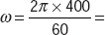 41.89 rad/sec
Power Transmission capacity P = 41.89 × 277.875 = 11,640 Nm/s = 11.64 kW
Shearing area per spline on shaft

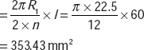

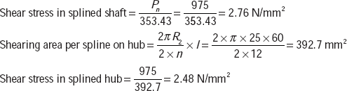

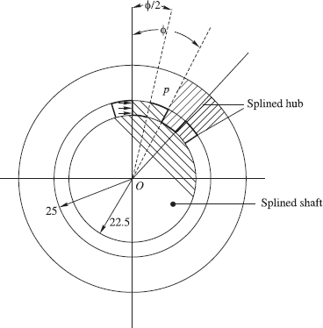

Figure 14-6

14-5 SPECIAL-PURPOSE KEYS
The following keys are used for undertaking very heavy or very light torques:
- Kennedy's keys
- Saddle key
- Tangent key
For the transmission of heavy torques, two square keys, rather than one, at right angles to each other, as shown in Fig. 14-7, are used. The arrangement is known as Kennedy's keys.
The torque is equally divided between two keys.
Tangential force on each key

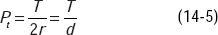

where, d is diameter of the shaft.
The key section is square, a × a. Say, length of key is l.
Area of the key under shear

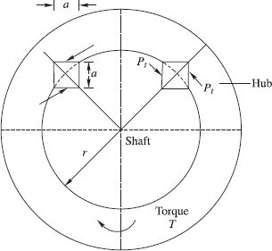

Figure 14-7 Transmission of heavy torque by two square keys

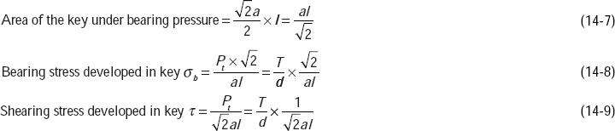
If σ_{a} and τ_{a} are allowable bearing stress and allowable shearing stress, respectively, for the material, then:

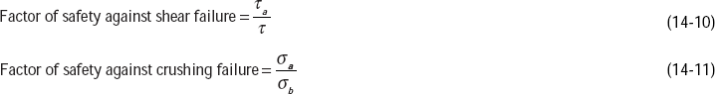

A flat saddle key, as shown in Fig. 14-8, is a taper key which fits in a keyway in the hub and is flush on the shaft. The friction between the shaft and the key is responsible for power transmission. The key is likely to slip around the shaft, under load. It is used only for light loads (See Fig. 14-8). A round key, as shown in Fig. 14-9, fits into a circular hole drilled partly in the shaft and partly in the hub. But this key is used for low power drive.
A tapered pin, as shown in Fig. 14-10, sometimes joins the shaft and bush. It is held in friction between the pin and the reamed tapered holes in the shaft and the hub.

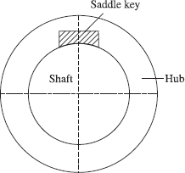

Figure 14-8 Saddle key

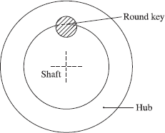

Figure 14-9 Round key

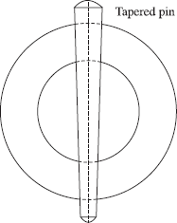

Figure 14-10 Tapered pin
4

SOLVED EXAMPLES
Example 14-3 Kennedy keys of 12 mm × 12 mm are used to connect a shaft of 50 mm diameter, transmitting 40 kW at 360 rpm. The keys are made of 40 C 8 steel with σ_{yt} = σ_{yc} = 380 N/mm². Taking a factor of safety of 3, determine the required length of the keys.
Solution:

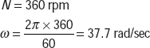

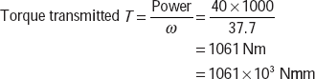

Shaft radius r = 25 25mm
Tangential force per key 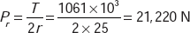
Section of the key = 12 × 12 mm
Length of the key = l mm

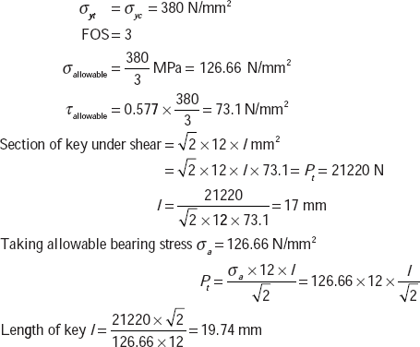

14-6 COUPLINGS
A wide variety of couplings are commercially available, ranging from a simple rigid coupling to elaborate flexible couplings using gears, elastomers and fluids for transmission of torque from one shaft to another shaft or from a shaft to a device. Couplings can be broadly classified into rigid and flexible couplings. Flexible couplings can absorb same misalignment between the two shafts, but rigid couplings do not permit misalignment between the two shafts. A rigid coupling locks the two shafts and allows no relative moment between them. There are three types of rigid couplings: (1) set-screw coupling, (2) rigid coupling, and (3) clamp coupling.
In a set-screw coupling, a hard set screw digs into the shaft through the hub. The coupling transmits both torque and axial load. These are used only for light loads and are not recommended because these loosen with vibrations.
The rigid coupling uses a standard key for transmission of power. Set screws are used in combination with a key, and are located at an angle of 90° to the key. For proper holding against vibrations, a cup point screw is used to dig into the shaft. For added security, a hole is drilled in the shaft for setting the screw. Two flanges with hub are provided on the two shafts to be connected. Hubs are keyed to the shafts and the flanges are joined with the help of bolts and nuts. A protective cover is provided on each flange, to ensure that the clothes of a worker do not get entangled with running bolts and nuts. Table 14-2 illustrates the design characteristics and uses of various protective rigid couplings.

Table 14-2 Coupling selection guide
Coupling Type | Characteristics And Uses
Rigid Flange Coupling | - Angular And Parallel Misalignment Between Coupled Shaft Is Negligible  - Frequent Uncoupling Is Required  - Keyed Or Splined To Each Shaft  - No Vibration Isolation Provided
Rigid Sleeve Coupling | - Easier To Remove And Install  - Requires High-Strength Bolts To Join
Rigid Compression Sleeve Coupling | - A Small In-Line Misalignment Can Be Tolerated  - The Friction Between Shaft And Coupling Is The Clamping Force
Elastomeric Couplings | - An Angular Misalignment Of 2°, Or A Parallel Misalignment 7 Mm, May Be Tolerated  - Easily Replaceable  - Electrical And Partial Vibration Isolation Provided  - Reduced Torsional Capacity In Comparison To Rigid Coupling
Flexible Metal Couplings | - Angular, In-Line And Parallel Misalignment May Be Accommodated At Higher Torques
Gear Couplings | - Used For Large Torque  - In-Line And Angular Misalignment Is Present
Spring Couplings | - Suitable For Low Torque And Large Angular Misalignment, Up To 60°
Schmidt Couplings | - Designed For Parallel Misalignment With Adequate Space Between Shafts To Accommodate Coupling  - Low Torque Application Used With Fractional HP Motors
Fluid Couplings | - Designed To Provide Vibration Isolation  - Can Be Used For A Wide Range Of Torque; From 1 To 373 KW, At 1,200 Rpm.

14-7 SLEEVE OR MUFF COUPLING
A sleeve or muff is inserted over the two shafts to be coupled, and a gib-head key is inserted between the sleeve and the shafts to provide a connection for torque transmission.

where, d is the diameter of the shaft.

A gib-head key is fitted in the keyways cut in the sleeve and in the shaft. A gib head is provided for easy assembly and removal of key.

14-7-1 Section of the Key
Half of the key is inserted into the keyways of the shafts.

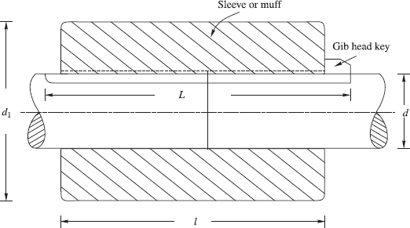

Figure 14-11 Sleeve or muff coupling

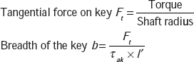

where, τ_{ak} = allowable shear stress in key with thickness (t).

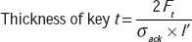

where, σ_{ack} = allowable crushing stress in key.
l′ = (length of the key in each shaft)

SOLVED EXAMPLES
Example 14-4 Design a sleeve coupling for the transmission of 12 kW at 300 rpm by two connected steel shafts. Take service factor K_{s} = 1.25. The sleeve is made of CI. The key and the shaft are made of the same material.
Allowable stress:
Shear stresses in key and shaft = 50 MPa
Crushing stress in key = 100 MPa
Shear stress in CI sleeve = 10 MPa
Solution:
Power = 12 Kw
Service factor K_{s} = 1.25
Design power P_{d} = 1.25 × 12 = 15kN
Speed N = 300 rpm

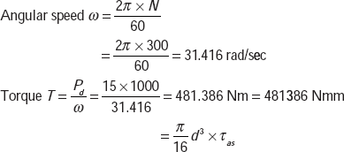

where, τ_{as} = allowable shear stress in shaft.

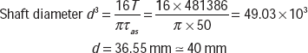

Sleeve
Allowable shear stress in sleeve = 10 MPa
Outer diameter of sleeve = d₁ mm = 2d + 13 = 93 mm
Shear stress developed in sleeve of CI:

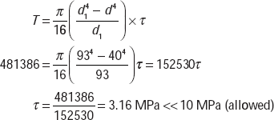

Length of the sleeve l = 3.5 × 40 = 140 mm
Key

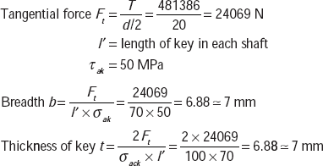

14-8 CLAMP COUPLING
Two shafts to be joined by a coupling are butt against each other. Two halves of the muff are joined to the shaft with the help of a tapered rectangular key, as shown in Figure 14-12. The halves of the muff, made of CI, are clamped to the shaft with the help of nuts and bolts. This coupling is used for heavy duty and moderate loads. There is even number of bolts and nuts: 2, 4 and 6. Figure 14-12 shows the two halves joined with the help of four sets of bolts and nuts, i.e., two on each shaft. The nuts and bolts are recessed into the bodies of the two halves.

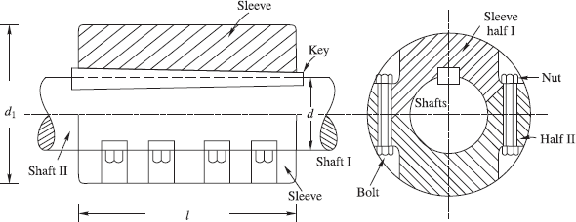

Figure 14-12 Clamp coupling

Outer diameter of muff d₁ = 2d + 13 mm
Length of the sleeve b = 3.5d where, d is diameter of shaft
Say, torque transmitted by coupling is T
Root diameter of bolt = d_{r}
Number of bolts = n
Number of bolts on each shaft =
Allowable tensile stress in bolt = σ_{atb}
Coefficient of friction between the surfaces of shaft and sleeve = μ
Length of muff = l
Permissible force exerted by each bolt = 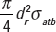

Say, pressure (radial) between shaft and sleeve is p.

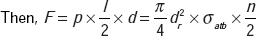

Frictional force between each shaft and muff = μF

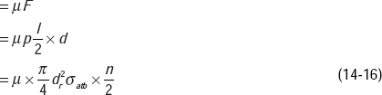

Torque transmitted by coupling, T = μF × d × π ×

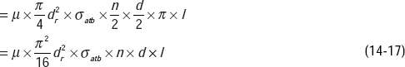

Equation (14-17) gives the root diameter of the bolt.

SOLVED EXAMPLES
Example 14-5 Design a clamp coupling for transmitting 36 kW, at 200 rpm. Allowable shear stress in shaft is 45 MPa, allowable shear stress in key is 40 MPa, and allowable crushing stress in key is 90 MPa. The number of bolts joining the two halves is 4. The permissible tensile stress in bolts is 60 MPa. The coefficient of friction between the muff and shaft can be taken as 0.25.
Solution
Power = 36 kW 36000 Watts
Speed =200 rpm

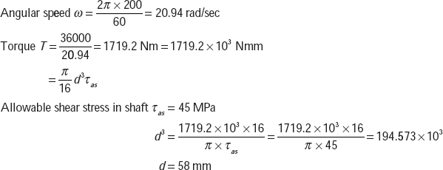

Let us take, d = 60 mm.
Outer diameter of shaft d₁ = 2d + 13 = 2 + 60 + 13 = 133mm
Length of shaft l = 3.5d = 3.5 × 60 = 210mm
Key

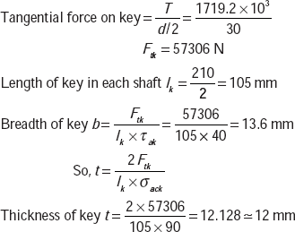

Key size = 14mm × 12mm
Length = 210mm.
Bolts
Number of bolts n = 4
σ_{atb} = 60 MPa
d = 60 mm (shaft diameter)
l = 210 mm
= 0.25 (coefficient of friction between shaft and sleeve)

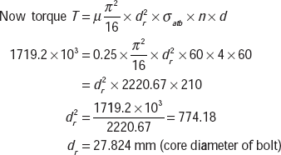

M 30 coarse thread has d_{r} = 27.727. M 30, with a pitch of 3.5 mm, can be selected for the clamp coupling.

POINTS TO REMEMBER
- Keyways are cut in the shaft and hub and a key is inserted to provide mechanical joint between shaft and hub to transmit power.
- Depending upon the type of alignment between two shafts to be connected and angular position of shaft axes, different types of couplings are used.
- Parallel keys are most commonly used, tapered key causes slight eccentricity between shaft and hub.
- A keyway changes the geometry of shaft and, thus, causes stress concentration in shaft.
- Splines are built in keys on shaft and hub and are used for more torque transmission and can accommodate large axial movement.
- Kennedy's keys are used for heavy torque transmission.
- Flat saddle key is used for light loads.
- Flexible coupling can take up some misalignment between two shafts.
- In flange couplings, bolts are used to connect flanges.
- In sleeve or muff coupling a gib-head key is inserted between the shaft and the sleeve.
- The two halves of a muff made of CI are joined to the shaft with the help of bolts and nuts.
- Since couplings are subjected to fluctuating stresses and vibrations, fine-threaded bolts are used.
- The projected portion (spigot) of one flange fits into the recess (socket) of another flange.
- In flange couplings for marine applications, the flange is integrally forged with the shaft.
- In flexible couplings a rubber bush is a flexible element, which allows a small amount of misalignment between two shafts.

PREVIEW QUESTIONS
- What is the function of key in shaft and hub assembly?
- List the couplings for following applications:
  - Heavy torque transmission
  - Light torque transmission
  - Shafts with misalignment in axes
  - Shafts laterally displaced
- Identify the locations of regions of stress concentration in key and keyway.
- What are the merits and demerits of involute splines with trapezoidal splines?
- What are different types of couplings?
- Compare the principle of operation of flexible coupling with rigid coupling.
- What type of coupling is used in marine power transmission?

